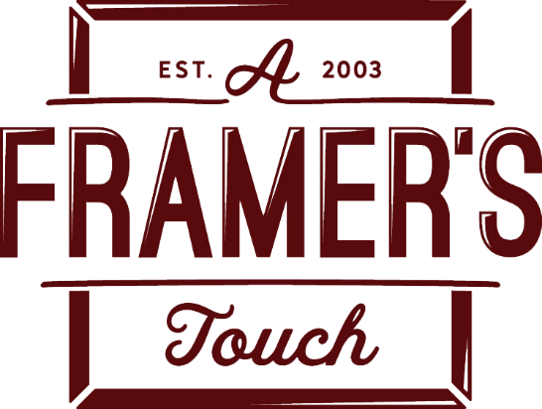

2022 Holiday Ornaments - call to artists
A Framer’s Touch has the largest selection of Holliday Ornaments around. This year we will be holding our 7th annual Festival of Ornaments on
November 11th,12th and 13th.

In celebration of Forest Grove’s sesquicentennial, we encourage you to draw inspiration from our community for your ornaments. We are looking for artists that are unique and think “outside of the box”. If you believe that your locally made ornaments would fit our gift gallery, we would love to hear from you!

To apply: Email your name, contact info, retail price and photos representing the type of ornaments you would bring to the Gallery. Limited space, contact us ASAP at gallery@aframerstouch.com. Please add Holiday Ornaments in the subject of your email.
You will be notified if you are selected as an artist and a contract will be drafted, artist commission is 60/40. Ornaments must be delivered by October 14th, 2022.

To see past events & artist exhibits, visit us online
www.aframerstouch.com/event-photos
facebook.com/aframerstouch

A Framer’s Touch
1920 21st Ave. Ste A
Forest Grove, OR 97116
503-359-5109

